SD382 Kerosene smoke point tester
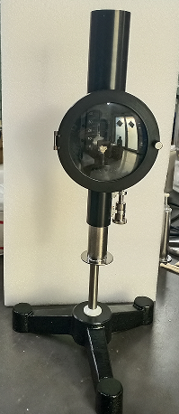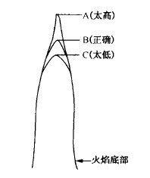
Kerosene smoke point tester is designed and manufactured according to GB/T382-2017 "kerosene smoke point determination method" standard provisions.
For the determination of the smoke point of kerosene and jet fuel for lamps, that is, the maximum height of a smokeless flame under specified conditions when a sample is burned in a standard lamp, expressed in millimeters.Kerosene and jet fuel smoke point lampwick comply with GB/T382-2017.Determination of smoke point of kerosene and jet fuel GT;ASTM D 1322Standard Test Method for Kerosene and Aircraft Turbine Fuel Smoke Point, for the determination of the smoke point of kerosene and jet fuel for lamps.
Smoke point, also known as the height of smokeless flame, refers to the maximum height of the smokeless flame when the sample is burned in a standard lamp under specified conditions, expressed in millimeters (mm).
The sample oil is burned in a standard lamp, and the change of flame height is reflected on the millimeter scale background.
During measurement, the wick is raised to the point where there is smoke, and then lowered to the point where the smoke tail has just disappeared. The flame height at this point is the smoke point of the sample.
Compliant with standards | GB/T382
Test sample | Petroleum and chemical products
detection result | Measure the smoke point of kerosene and jet fuel, which is the maximum height of a smokeless flame when the sample is burned under specified conditions in a standard lamp, expressed in millimeters
Functional features
- The kerosene smoke point tester adopts millimeter scale background, which can clearly read the data
- The whole instrument structure is compact and complete
- The kerosene smoke point tester adopts plug type structure, the replacement of lampwick is more convenient
- The kerosene smoke point tester adopts special glass observation window, easy to operate
- The kerosene smoke point tester is easy to operate and has high repeatability
Technical parameters
- Ruler: the ruler should be marked with white on the black glass, and the white or black stripes of 2 mm in the center of the ruler should be vertically divided into two halves.The measuring range of the ruler shall be 50 mm and the grading shall be 1 mm.Number every 10 millimeters and mark every 5 millimeters with longer lines.
- Wick guide: the top of the wick guide should be precisely at the same level as the zero point on the ruler.
- Lifting seat: the total distance of travel should not be less than 10 mm, smooth and uniform when moving.
- Ф oil container: fuel reservoir is mainly composed of fuel reservoir ontology, the wick and other components of the pipe and air duct, the critical dimension in line with the GB/T382,
- Oil container ontology Ф diameter is 21.25 0.05 mm, length of 109.0 0.05 mm;
- Wick pipe inner Ф 4.7 0.05 mm, length is 82.0 0.05 mm;
- Air duct Ф diameter is 3.5 0.05 mm, 90.0 0.05 mm length.
- Packing size: 280×260×495
- Weight: 4.29 kg
Packing list
S/N | Name | Unit | Quantity | Remarks
１ | M ain engine | set | １
２ | Oil storage tank | piece | 1
３ | Wick | piece | 2
4 | Instructions | Copy | 1
5 | Certificate of conformity warranty card | copy | 1

